Name: Shruti Popat Patil

Roll no.: 243549

**Python Assignment 4**

Write programs using lists in python

1. Reverse a given list in Python

aList = [100, 200, 300, 400, 500]

output:

[500, 400, 300, 200, 100]

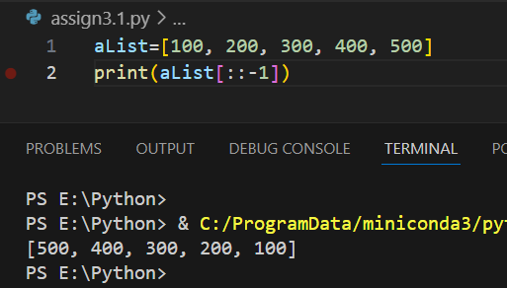

2. take a list 'l1' of even nos between 150 to 250. Print its length.

Then create another list 'l2' using 'l1', containing only nos divisible by 4 from 'l1'.

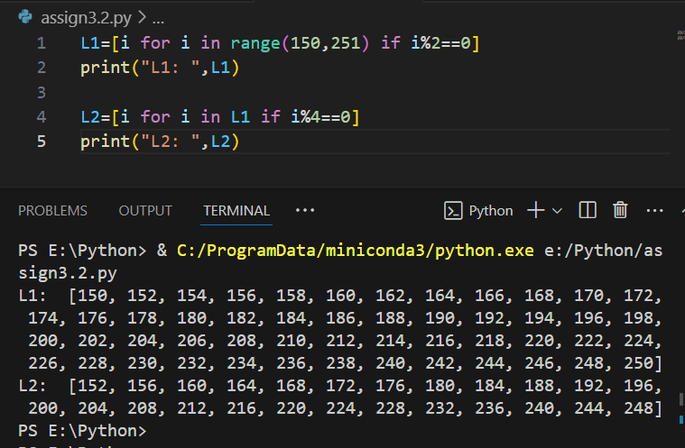

3. Given a Python list of numbers. Turn every item of a list into its square root

aList = [1, 4, 9, 16, 25, 36, 49]

output:

[1, 2, 3, 4, 5, 6, 7]

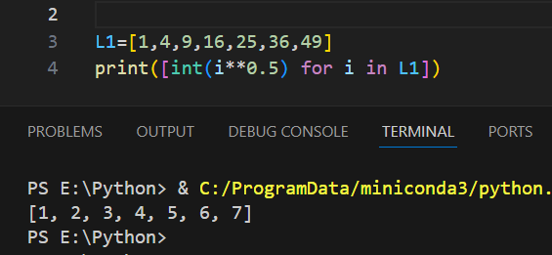

4. Print two lists in the following order

list1 = [5, 6,7]

list2 = [0, 1]

output:

50,51,60,61,70,71

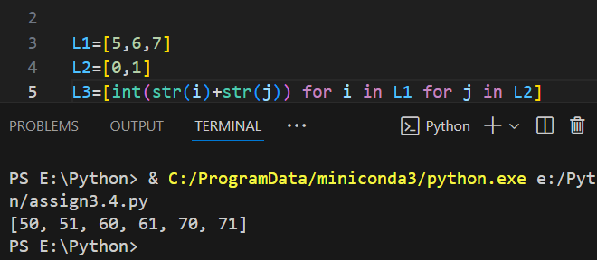

5. Given a two Python list. Iterate both lists simultaneously such that list1 should display item in original order and list2 in reverse order. It should work for any two lists.

list1 = [10, 20, 30, 40]

list2 = [100, 200, 300, 400]

output:

10 400

20 300

30 200

40 100

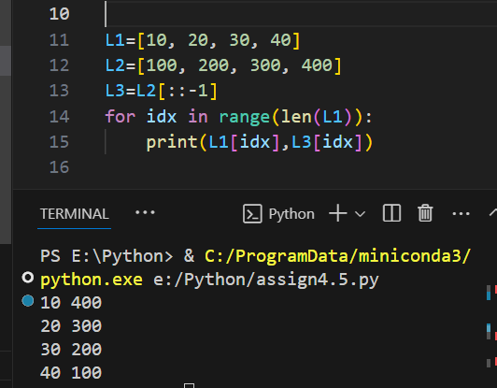

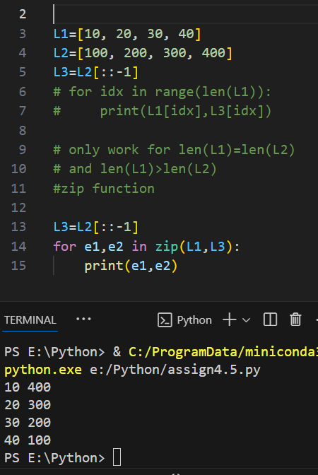

6. Remove empty strings from the list of strings

list1 = ["Ashish", "", "Atharva", "Amit", "", "Revati"]

output:

["Ashish", "Atharva", "Amit", "Revati"]

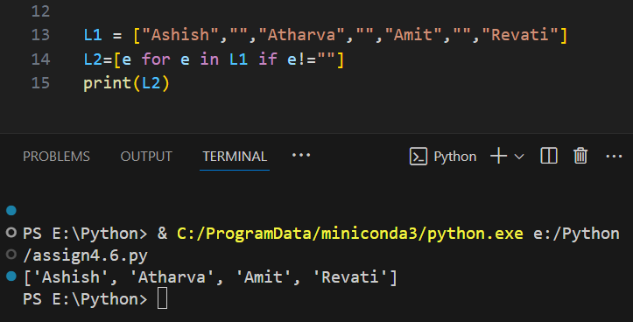

7. Add item 7000 after 6000 in the following Python List

list1 = [10, 20, [300, 400, [5000, 6000], 500], 30, 40]

output:

[10, 20, [300, 400, [5000, 6000, 7000], 500], 30, 40]

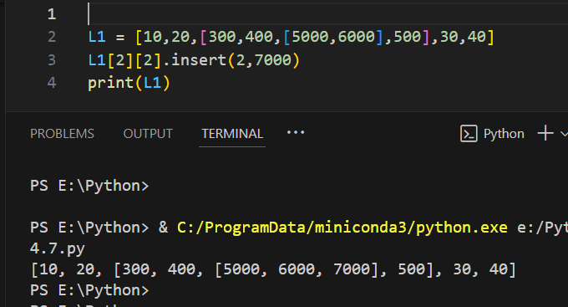

8. Given a nested list extend it by adding the sub list ["h", "i", "j"] in such a way that it will look like the following list

list1 = ["a", "b", ["c", ["d", "e", ["f", "g"], "k"], "l"], "m", "n"]

Sub List to be added = ["h", "i", "j"]

output:

['a', 'b', ['c', ['d', 'e', ['f', 'g', 'h', 'i', 'j'], 'k'], 'l'], 'm', 'n']

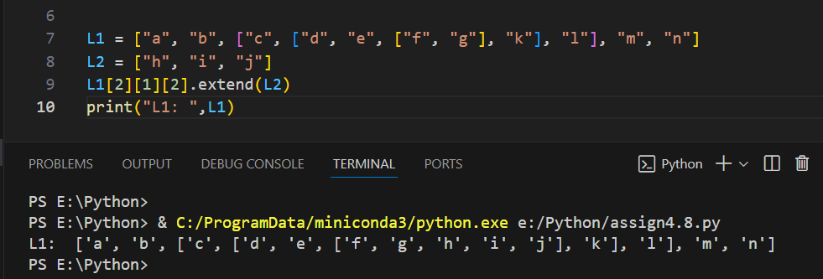

9. Given a Python list, find value 20 in the list, and if it is present, replace it with 200. Only update the first occurrence of a value

list1 = [5, 10, 15, 20, 25, 50, 20]

output:

list1 = [5, 10, 15, 200, 25, 50, 20]

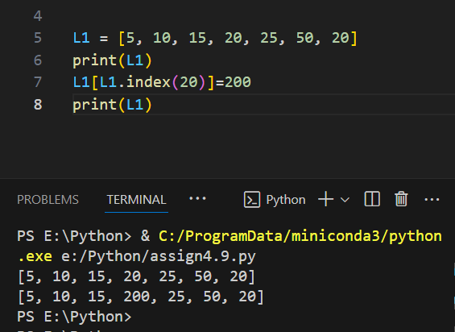

10. Given a Python list, remove all occurrence of 20 from the list

list1 = [5, 20, 15, 20, 25, 50, 20]

output:

[5, 15, 25, 50]

